**Entity Relationship Diagram [50%]**

1. **From the above diagram, list all of the objects including its attributes! (.pdf)**

Answer:

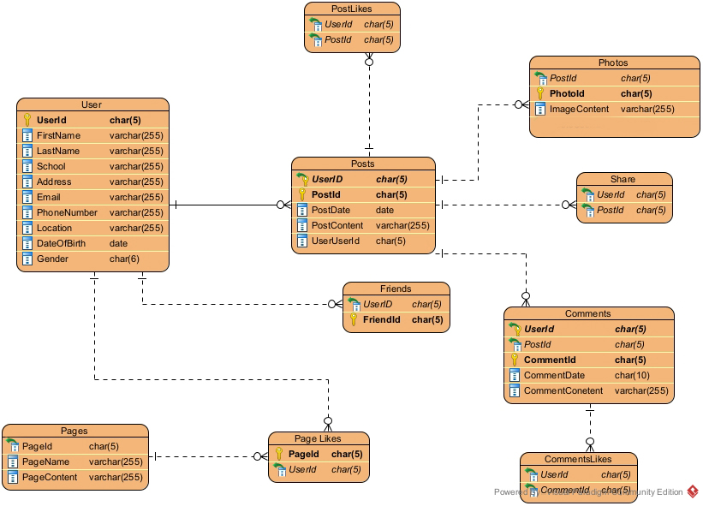

Objects & atrributes

1. **Determine the relation between every object, specify the master and child table! (.pdf)**

Answer:

Posts (Master)

PostLikes (Child)

Photos (Child)

Share(Child)

1. **For each object, decide its constraint and specify the reason in detail! (.pdf)**

Answer:

Char hanya 5 kode unik

Varchar bisa 255 karena tidak perlu penuh semua dan 255 limit

1. **Draw the above diagram in "ERD format" which includes the data types, primary and foreign key, and relation between objects. Please choose appropriate tools, we recommend using Visual Paradigm. (.jpeg)**

Answer:



ERD

**Data Definition Language [50%]**

1. **Explain what is data integrity and how do we maintain it in SQL Server! (.pdf)**

Answer:

*Make sure that the data is organized and prevents data redundancy*

1. **Explain the difference and give example for: primary key, foreign key, and composite key! (.pdf)**

Answer:

Primary Key : Suatu aturan untuk memastikan data pada tabel tersebut bersifat unik

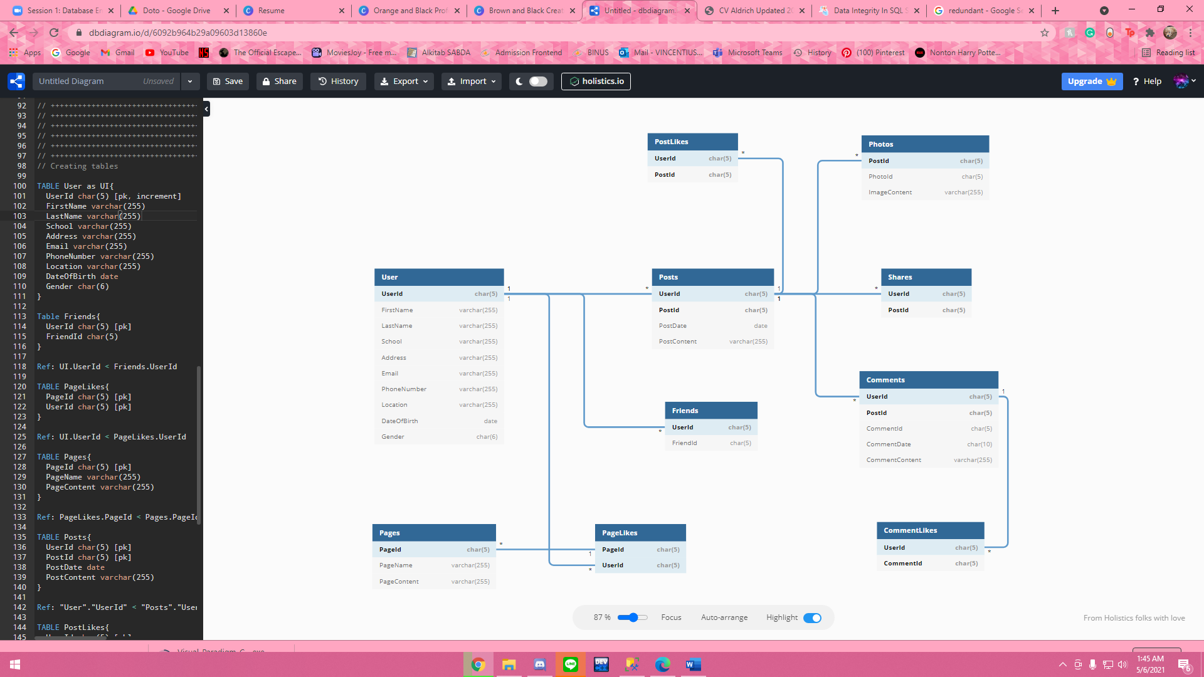

Contoh Primary key

Foreign Key : Kunci relasi antar tabel. Maksudnya adalah sebagai penyambung tabel tabel

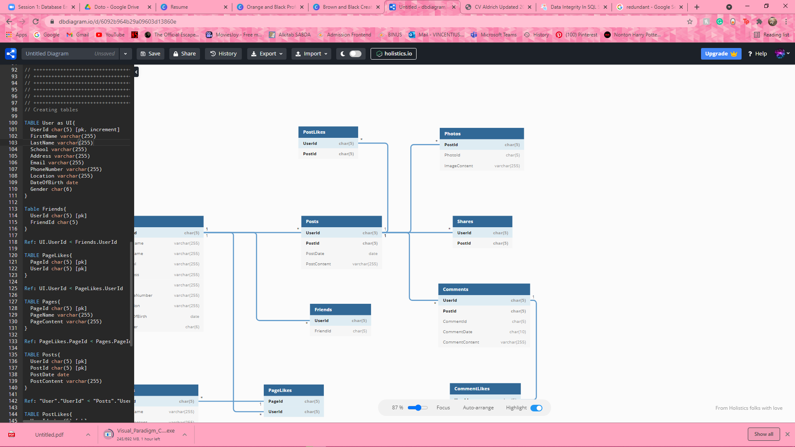  
Contoh Foreign Key

Composite Key : Kombinasi dari PK FK

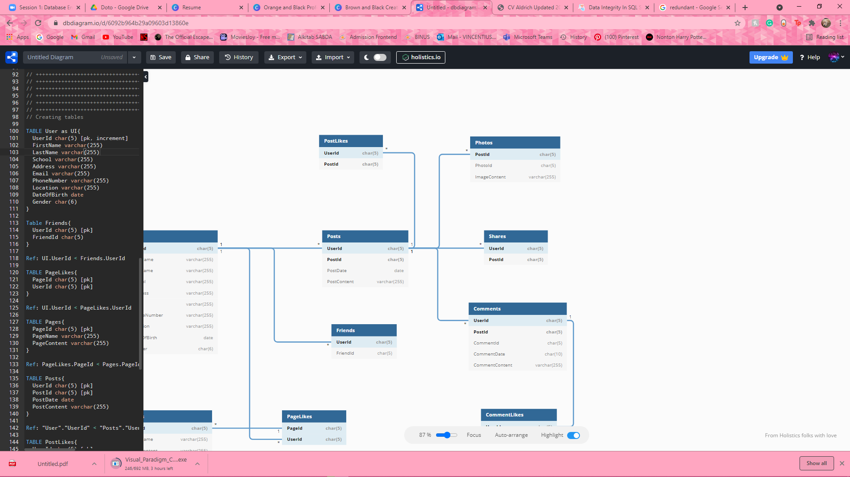

Contoh dari PK FK (UserId)

1. **Explain the following terms and give example: BEGIN TRAN, COMMIT, and ROLLBACK! (.pdf)**

Answer:

Begin Tran : CheckPoint

Rollback : *Undo*

Commit : Tidak bisa *undo*, perubahan tetap dan tidak bisa dirubah kembali

1. **Create all of the tables above according to your answer in the previous section! (.sql)  
   Answer:**

CREATE DATABASE DBSTheoryExam1

drop table [user]

drop table Friends

drop table Pages

drop table PageLikes

drop table Posts

drop table PostLikes

drop table Photos

drop table Shares

drop table Comments

drop table CommentLikes

CREATE TABLE [user] (

UserId CHAR(5) PRIMARY KEY CHECK (UserId LIKE 'US[0-9][0-9][0-9]'),

FirstName VARCHAR(255) NOT NULL,

LastName VARCHAR(255) NOT NULL,

School VARCHAR(255) NOT NULL,

[Address] VARCHAR(255) NOT NULL,

Email VARCHAR(255) CHECK (Email like '%@%.com'),

PhoneNumber VARCHAR(255) NOT NULL,

[Location] VARCHAR(255) NOT NULL,

DateOfBirth date NOT NULL,

Gender CHAR(6) NOT NULL

)

INSERT INTO [user]

VALUES

('US001', 'VINCENT', 'ELROY', 'BINUS', 'Jalanan', 'elroy@gmail.com', '081299097788', 'Tangerang', '2002-02-15', 'Female')

SELECT * FROM [user]

SELECT UserId,

PhoneNumber,

Email

FROM [user]

INSERT INTO [user]

VALUES

('US002', 'Pikri', 'ELROY', 'UI', 'Jalanan', 'PIKRI@gmail.com', '081210210352', 'Depok', '2001-02-23', 'Male')

CREATE Table Friends(

UserId CHAR(5) FOREIGN KEY REFERENCES [user](UserId) ,

FriendId CHAR(5) PRIMARY KEY CHECK (FriendId LIKE 'FR[0-9][0-9][0-9]')

)

CREATE TABLE Pages(

PageId CHAR(5) PRIMARY KEY CHECK (PageId LIKE 'PG[0-9][0-9][0-9]'),

PageName VARCHAR(255) NOT NULL,

PageContent VARCHAR(255) NOT NULL

)

CREATE TABLE PageLikes(

PageId CHAR(5) FOREIGN KEY REFERENCES Pages(PageId),

UserId CHAR(5) FOREIGN KEY REFERENCES [user](UserId),

)

CREATE TABLE Posts(

UserId CHAR(5) FOREIGN KEY REFERENCES [user](UserId),

PostId CHAR(5) PRIMARY KEY CHECK (PostId LIKE 'PO[0-9][0-9][0-9]'),

PostDate date NOT NULL,

PostContent VARCHAR(255) NOT NULL,

)

CREATE TABLE PostLikes(

UserId CHAR(5) FOREIGN KEY REFERENCES [user](UserId),

PostId CHAR(5) FOREIGN KEY REFERENCES Posts(PostId)

)

CREATE TABLE Photos(

PostId CHAR(5) FOREIGN KEY REFERENCES Posts(PostId),

PhotoId CHAR(5) PRIMARY KEY CHECK (PhotoId LIKE 'PH[0-9][0-9][0-9]'),

ImageContent VARCHAR(255) NOT NULL

)

CREATE TABLE Shares(

UserId CHAR(5) FOREIGN KEY REFERENCES [user](UserId),

PostId CHAR(5) FOREIGN KEY REFERENCES Posts(PostId)

)

CREATE TABLE Comments(

CommentId CHAR(5) PRIMARY KEY CHECK (CommentId LIKE 'CM[0-9][0-9][0-9]'),

UserId CHAR(5) FOREIGN KEY REFERENCES [user](UserId),

PostId CHAR(5) FOREIGN KEY REFERENCES Posts(PostId),

CommentDate CHAR(10) NOT NULL,

CommentContent VARCHAR(255) NOT NULL

)

CREATE TABLE CommentLikes(

UserId CHAR(5) FOREIGN KEY REFERENCES [user](UserId),

CommentId CHAR(5) FOREIGN KEY REFERENCES Comments(CommentId)

)